**JOBSHEET 10**

**Queue**



**Name**

Sherly Lutfi Azkiah Sulistyawati

**NIM**

2341720241

**Class**

1I

**Major**

Information Technology

**Study Program**

D4 Informatics Engineering

**Practicum 1**

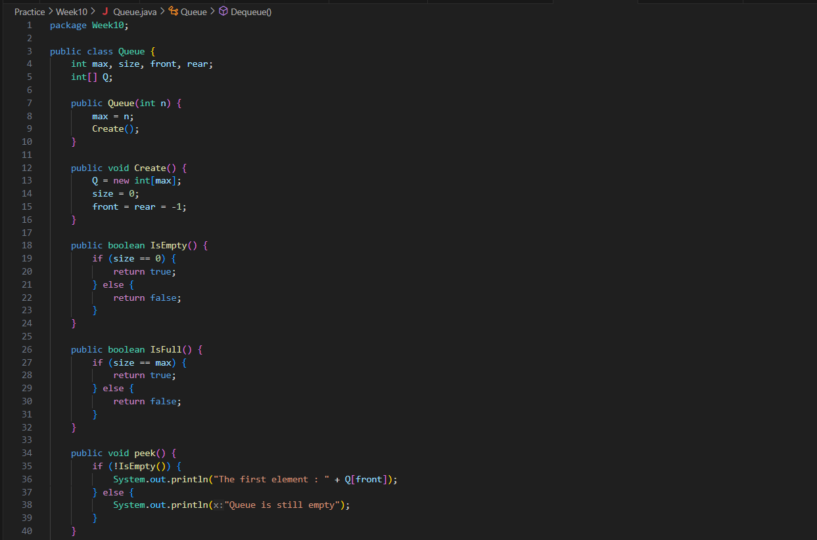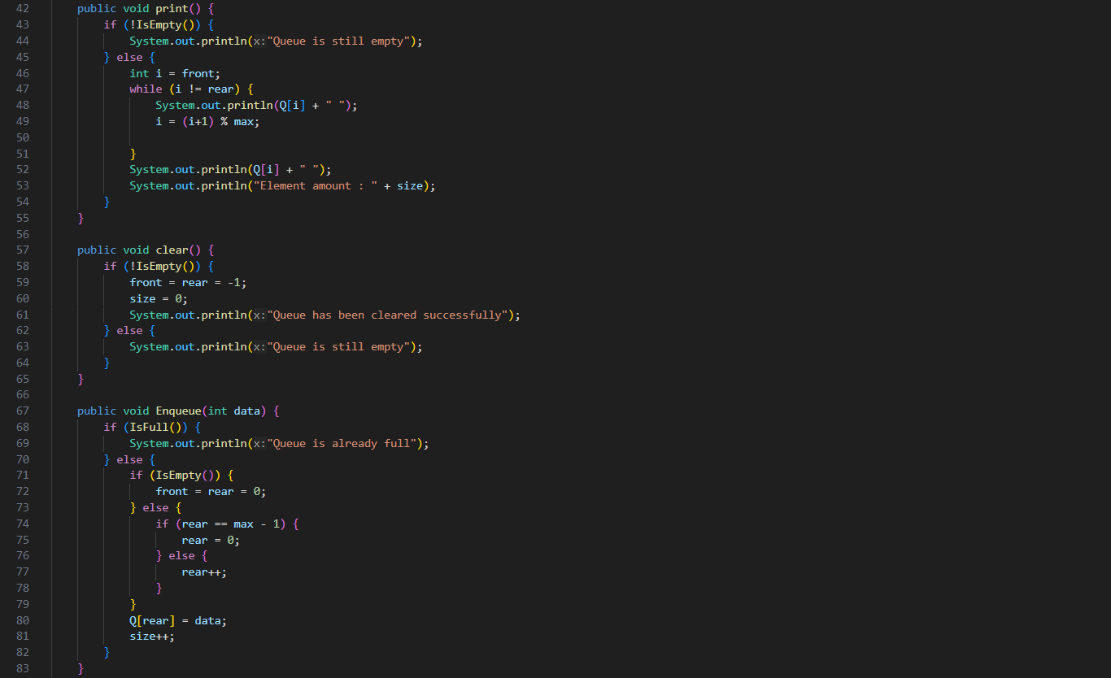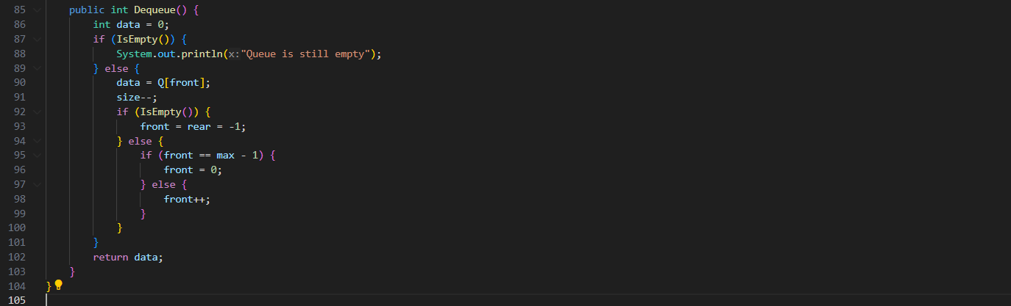

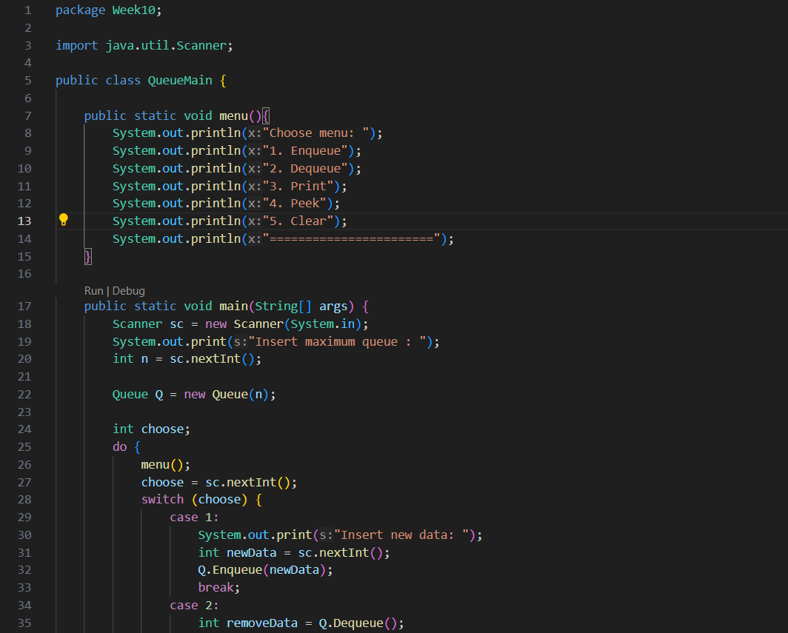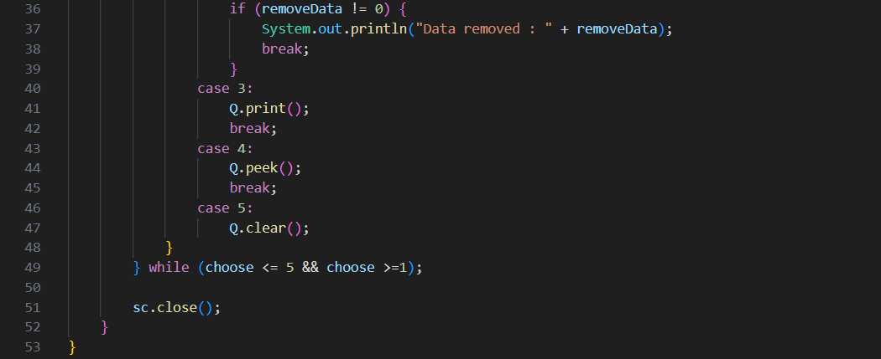

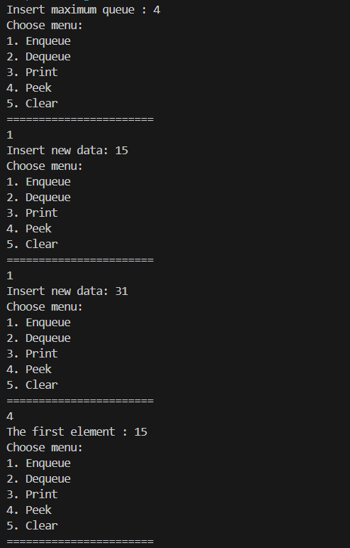

**Question**

1. In method create(), why is the front and rear attribute has initial value with 1 and not 0?

- front and rear are initialized to -1 to signify an empty queue. -1 indicates an empty queue, not 1.

1. In method enqueue(), please explain the usage of this following code

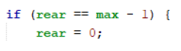

- if (rear == max - 1) checks if the rear pointer is at the end of the array. If so, it wraps around to the beginning by setting rear to 0.

1. Observe enqueue() method, which line of code indicates that the new data will be stored in last position of the queue?

- New data is stored in the last position of the queue with Q[rear] = data;.

1. Observe dequeue() method, which line of code indicates that the data is removed in the first position of the queue?

- Data is removed from the first position of the queue with data = Q[front];.

1. In dequeue method(), explain the usage of these codes !



- if (front == max - 1) handles wrapping the front pointer to the beginning of the array if it reaches the end.

1. In method print(), why the loop process has **int i = 0** instead of **int i=front**?

- The loop process in the print() method starts from int i = front; to ensure printing starts from the first element of the queue.

1. In method print(), please explain why we insert this code in our program?



- The line i = (i + 1) % max; for correctly traversing the circular queue and printing its elements without going beyond the array bounds.

**Practicum 2**

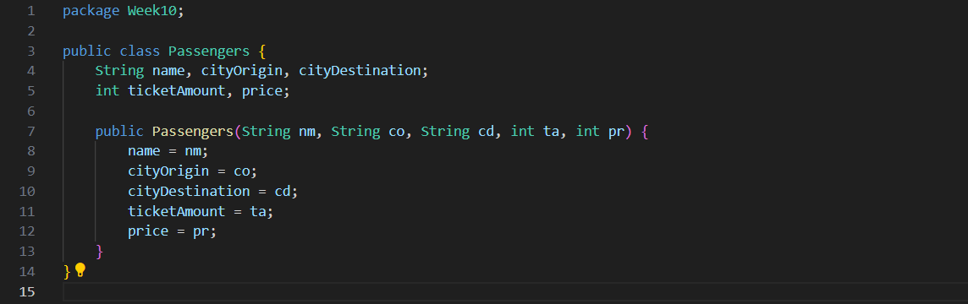

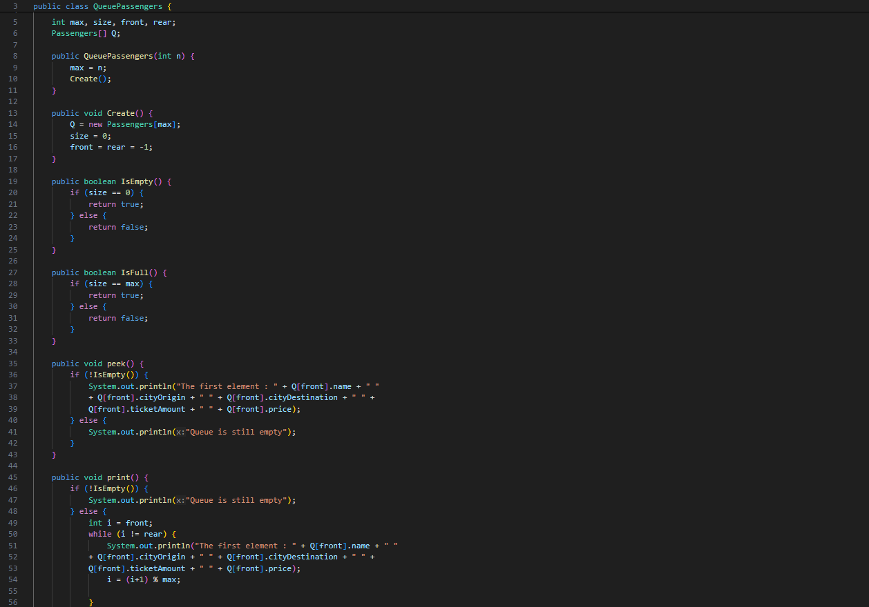

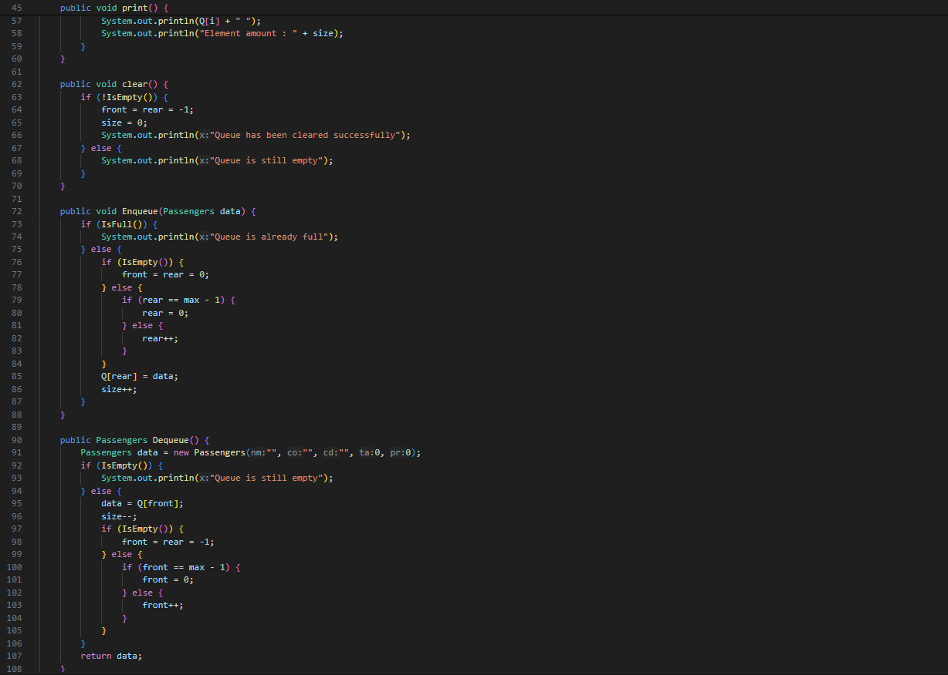

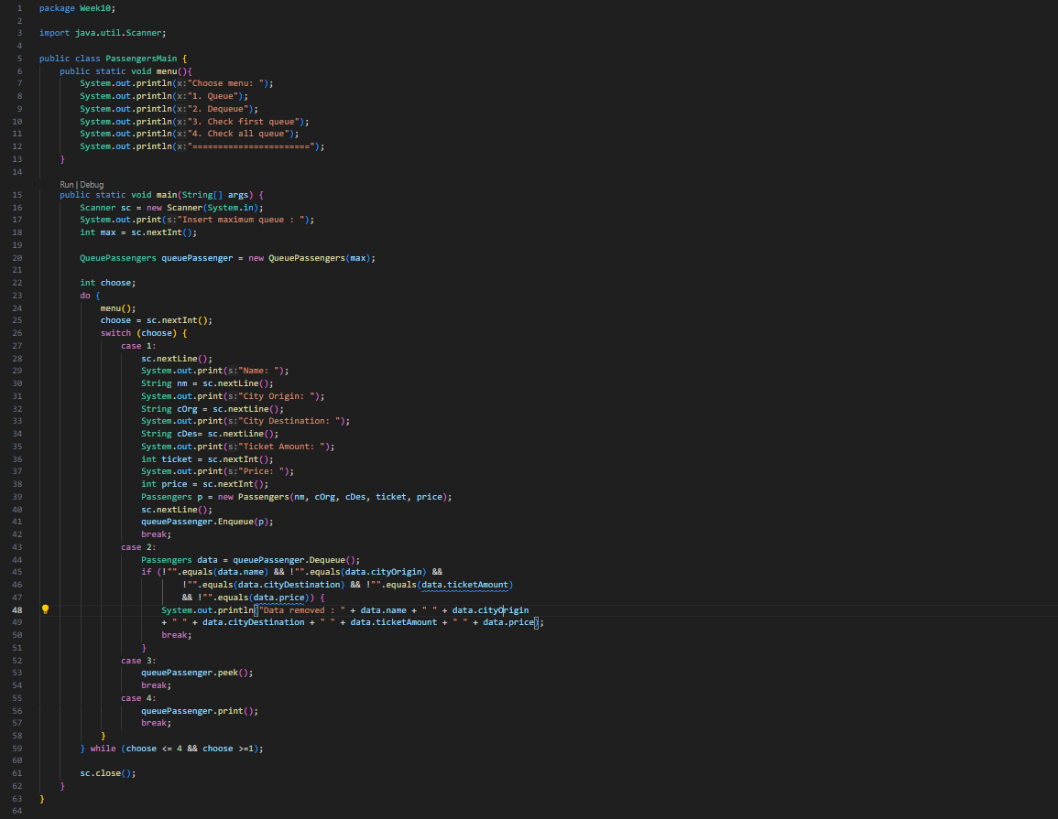

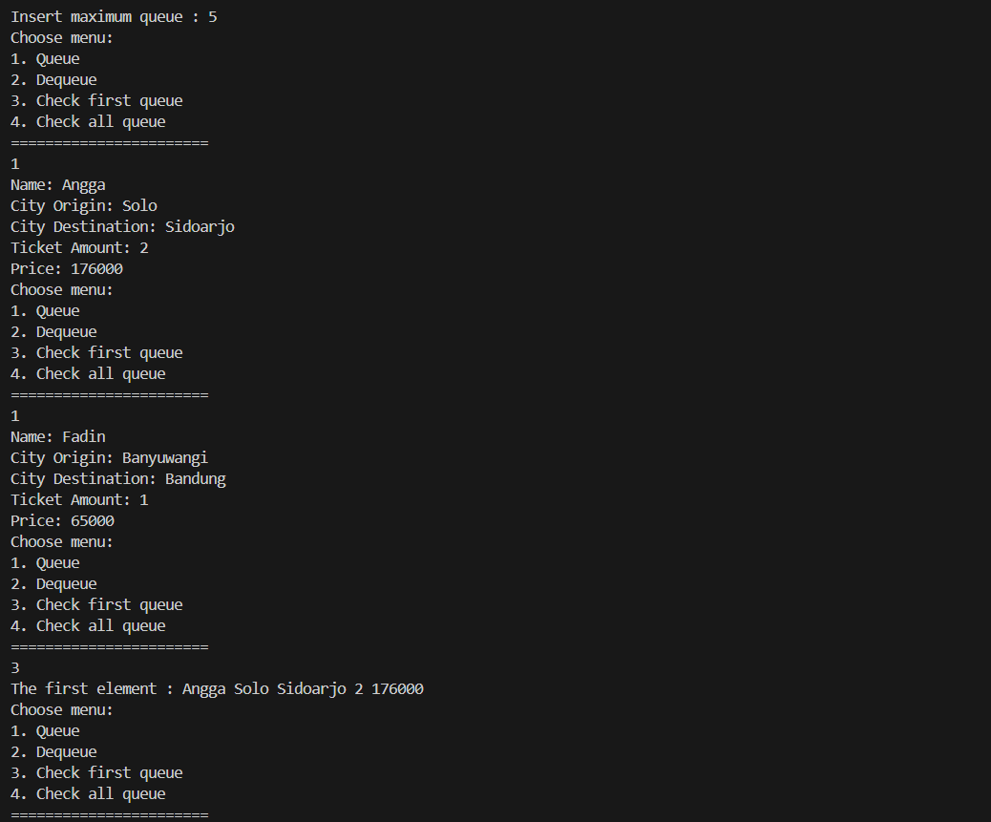

**Question**

1. In Queue Class, what’s the function of this program code in method Dequeue?

- The purpose of the code in the Dequeue() method is to remove an element from the front of the queue and return the dequeued data.

1. In previous number, if the program code changed to

Passenger data = new Passenger()

What will happen?

- Changing Passenger data = new Passenger() would create a new instance of Passenger with default values, not representing any actual data from the queue.

1. Show the program code used for displaying the data retrieved / removed from the queue!

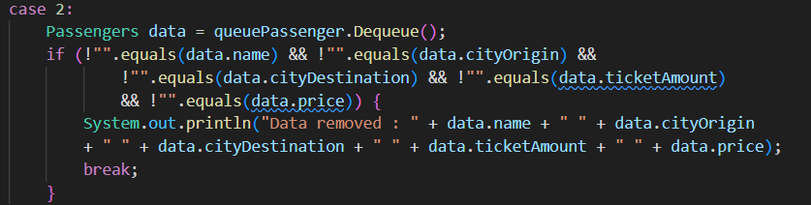

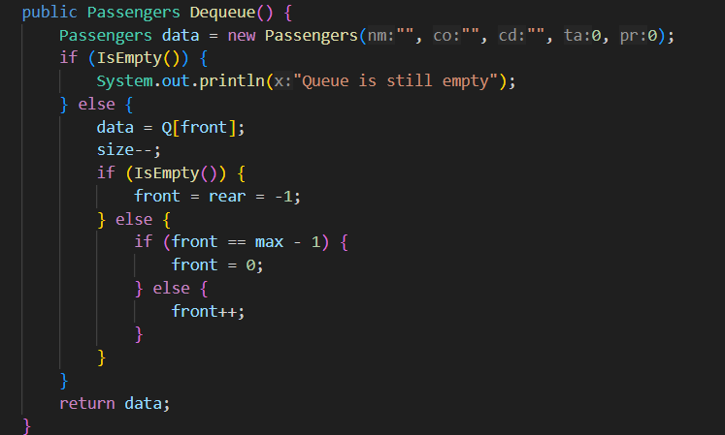

1. Modify the program by adding a method named peekRear() in Queue class to check the last position within the queue. Add a menu for the user to perform and explore your program as well

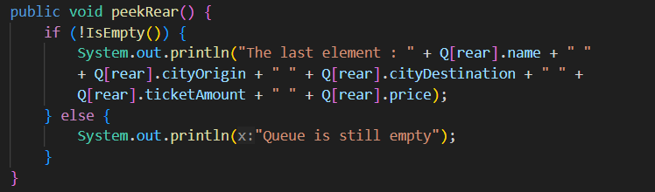

1. Ensure that the peekRear() function can be executed inside the program

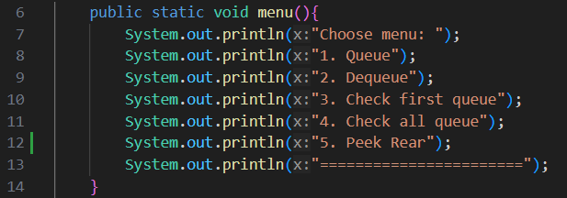

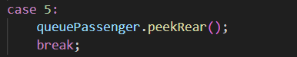

**Assignment**

1. Add these 2 methods in Queue class in 1st practicum
2. Make a queue program for students when they need the signs for their KRS by the DPA.

If the student is in queue, they will be required to fill in some information as follows:

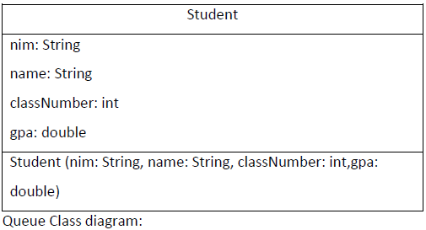 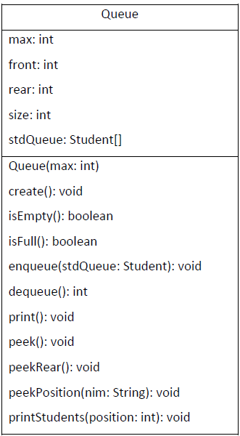

Notes:

* The implementation of Create(), isEmpty(), isFull(), enqueue(), dequeue() and print() functions are similar with we’ve built in practicum
* Peek() method is used for displaying students data in the first queue
* peekRead() method is used for displaying students data in the last queue
* peekPosition() method is used for displaying students data in the queue by their NIM
* printStudents() method is used for displaying a student data in specified position in a queue